Day 29 – 30/08/2025

Q1. Install DynamoDB and NoSQL workbench.

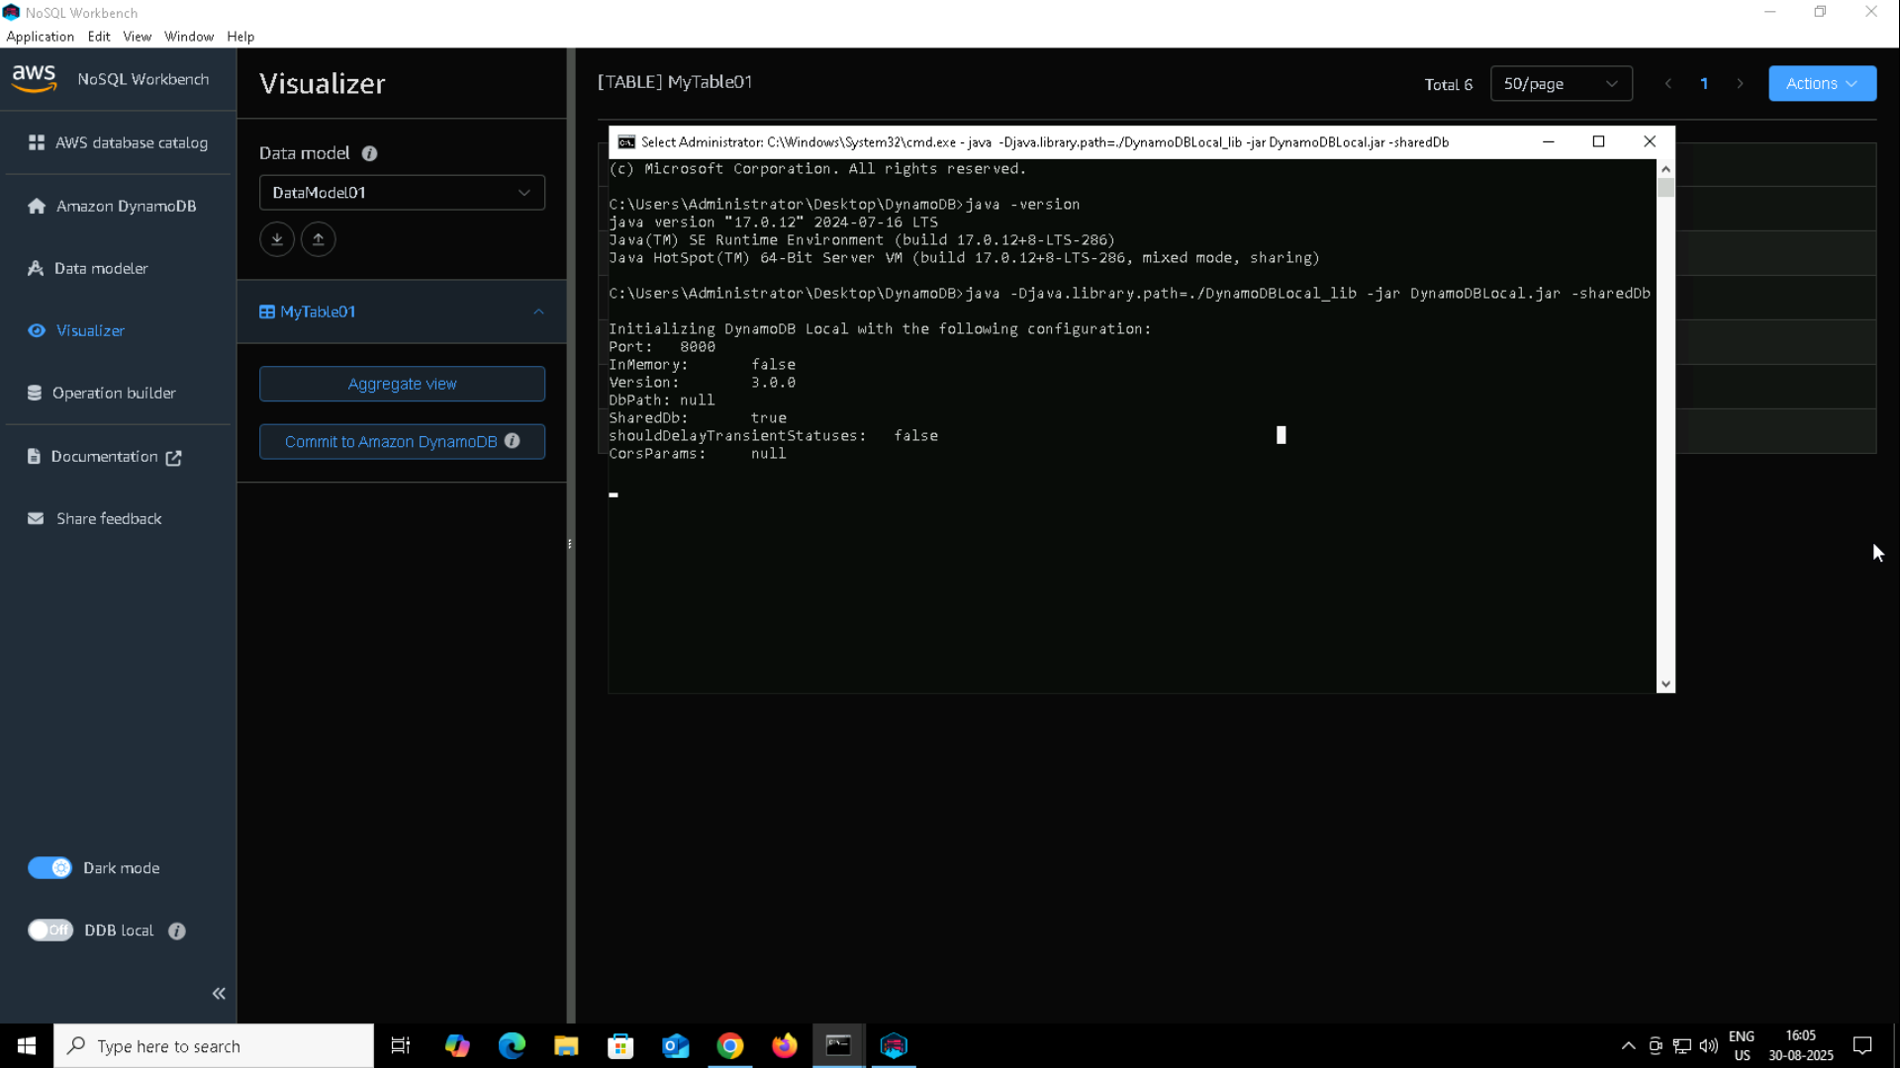

Q2. Create a table in NoSQL workbench – DynamoDB

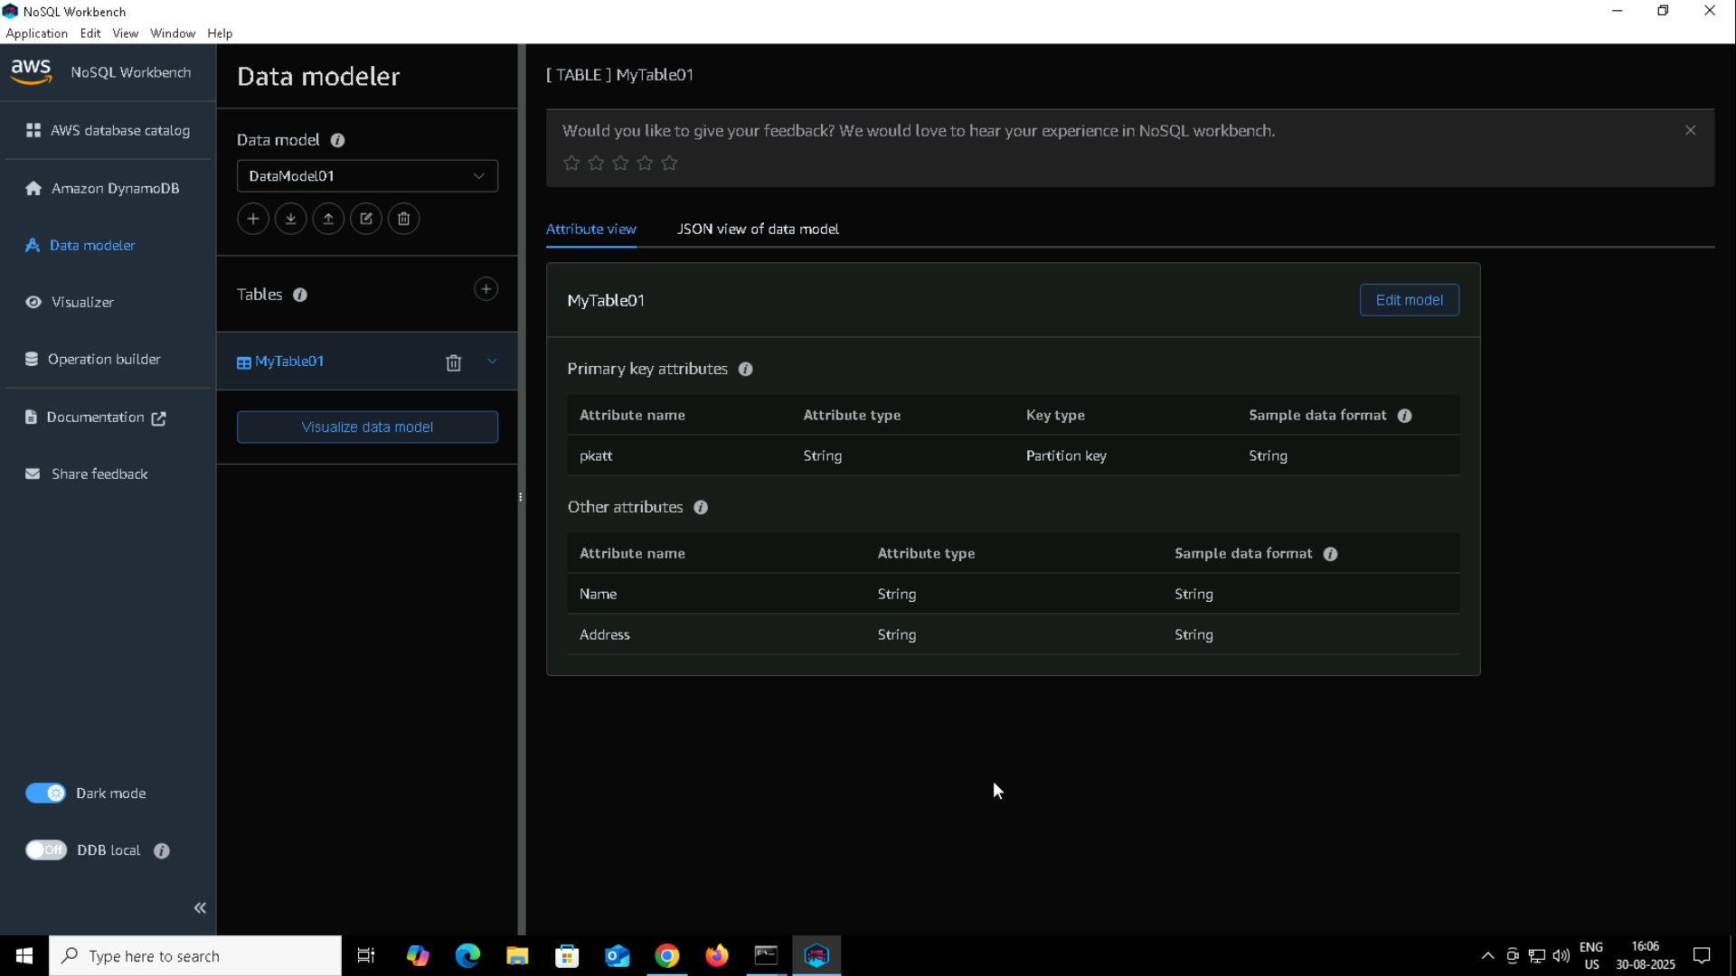

Q3. Create different connections with different numbers and see if it works … (also commit table to the DynamoDB.

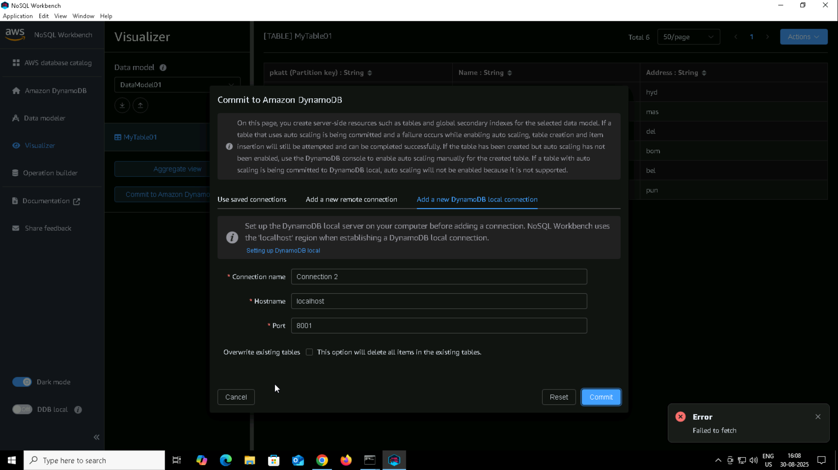

Q4. AWS CLI version

